**3.spring-rest-handson-outputs**

**Problem Statement - Display Employee List and Edit Employee form using RESTful Web Service**

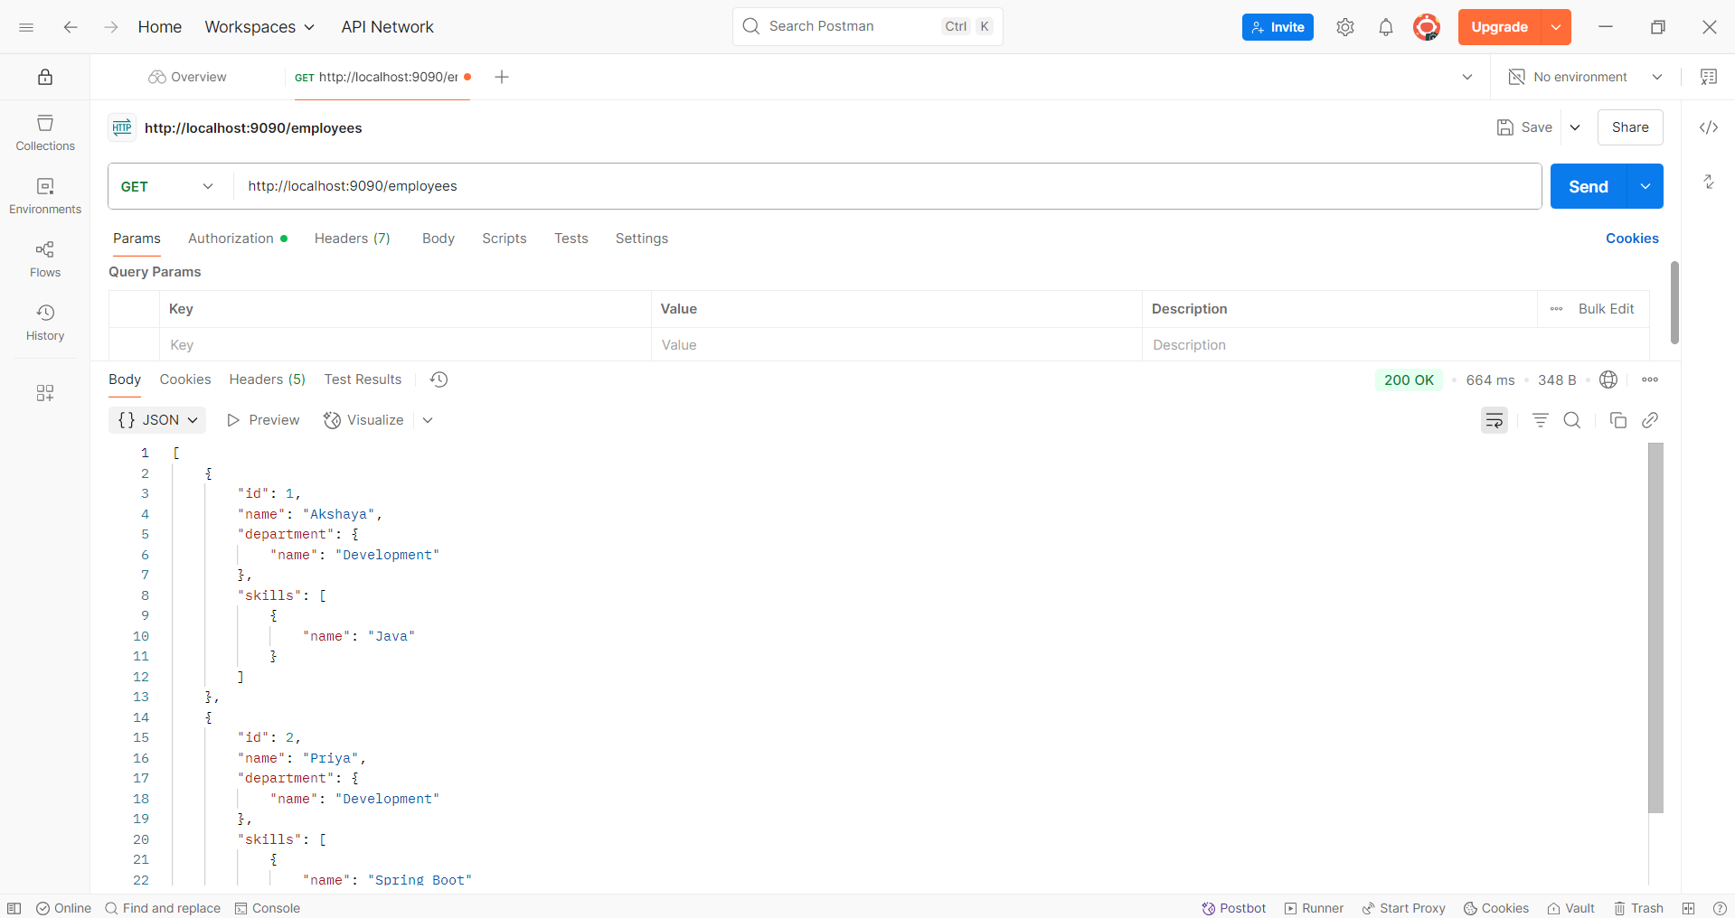

**Create static employee list data using spring xml configuration**

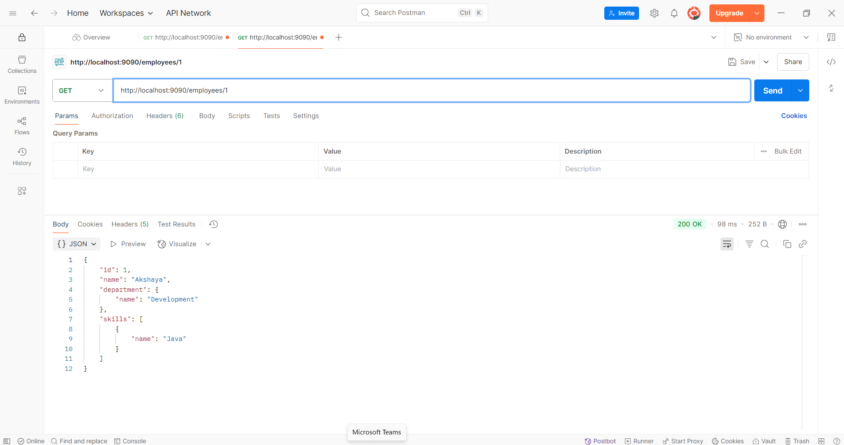

**Create REST service to gets all employees**

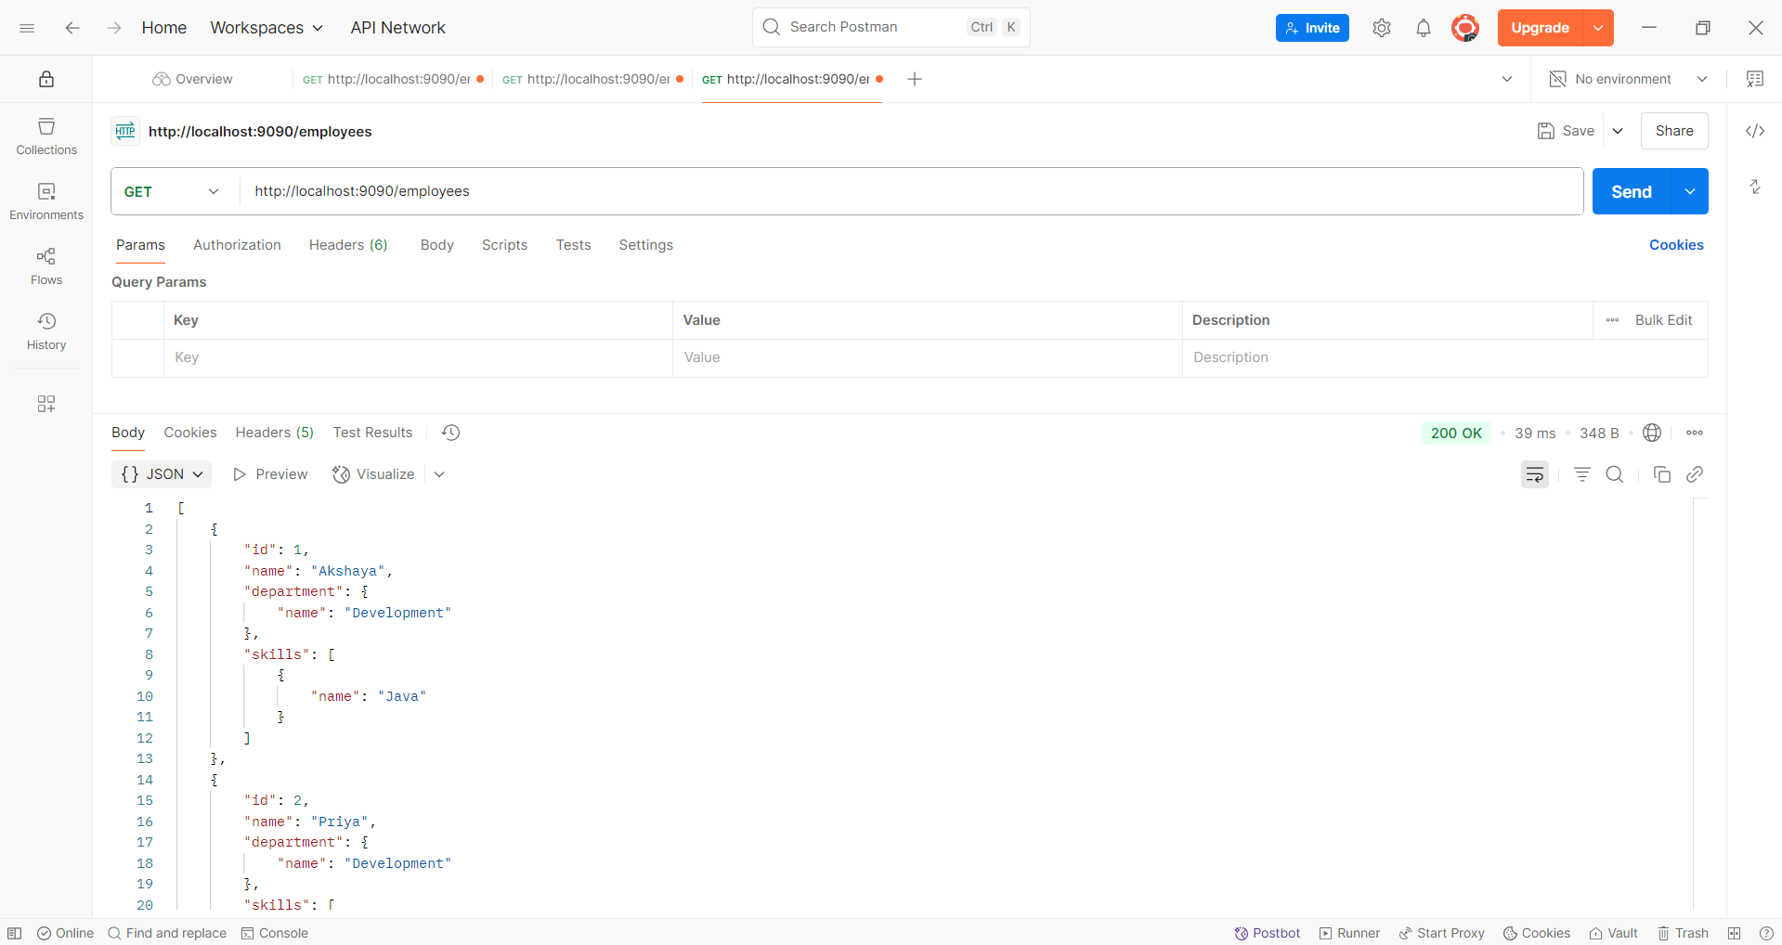

**Create REST service for department**

